Homework # 10 – T-tests using SPSS

- Independent Samples Test
H_{o} – there is no difference in how the parents from the two groups nag their children.
H_{a} – there is a difference in how the parents form the two groups nag their children.

Data:
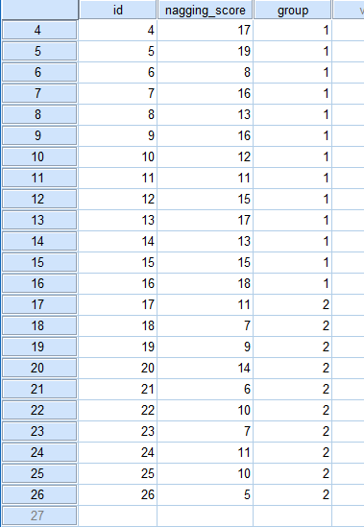

SPSS Output:
Group Statistics
 | group | N | Mean | Std. Deviation | Std. Error Mean
nagging_score | Group 1 | 16 | 14.13 | 3.052 | .763
nagging_score | Group 2 | 10 | 9.00 | 2.749 | .869

Independent Samples Test
 |  | Levene's Test for Equality of Variances |  | t-test for Equality of Means
 |  | F | Sig. | t | df | Sig. (2-tailed) | Mean Difference | Std. Error Difference | 95% Confidence Interval of the Difference
 |  |  |  |  |  |  |  |  | Lower | Upper
nagging_score | Equal variances assumed | .224 | .640 | 4.321 | 24 | .000 | 5.125 | 1.186 | 2.677 | 7.573
nagging_score | Equal variances not assumed |  |  | 4.431 | 20.804 | .000 | 5.125 | 1.157 | 2.718 | 7.532

Effect Size: Cohen’s d 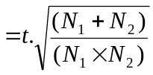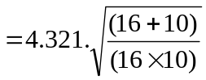 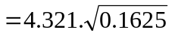 = 1.7418.
=> The effect size is Large

Conclusion: Twenty-six parents were taught how to monitor the frequency at which they nag their elementary –age children. They were randomly put into two groups for parenting skills geared to minimizing the nagging. Group - 1 consisted of 16 parents that were trained using Method 1, and Group – 2 used Method 2. The Levene’s test was significant (p = 0.640) which indicated that there was a homogeneity of variance among the group scores. That indicated an eligibility of doing a t-test. Thus, the counts were compared using t-test and found to be significantly different [t (24) = 4.321, p < .01]. We reject the null hypothesis, and it appears that Method 2 minimized the nagging more that Method 1.

- Paired Samples T-Test

H_{o} – there is no difference in the severity of the headaches.
H_{a} – there is a difference in the severity of the headaches.

Data:

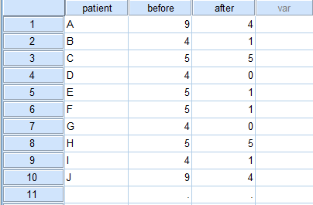

SPSS Output:

T-Test
Paired Samples Statistics
 |  | Mean | N | Std. Deviation | Std. Error Mean
Pair 1 | before | 5.40 | 10 | 1.955 | .618
Pair 1 | after | 2.20 | 10 | 2.044 | .646

Paired Samples Correlations
 |  | N | Correlation | Sig.
Pair 1 | before & after | 10 | .589 | .073

Paired Samples Test
 |  | Paired Differences |  |  |  |  | t | df | Sig. (2-tailed)
 |  | Mean | Std. Deviation | Std. Error Mean | 95% Confidence Interval of the Difference |  | t | df | Sig. (2-tailed)
 |  |  |  |  | Lower | Upper | t | df | Sig. (2-tailed)
Pair 1 | before – after | 3.200 | 1.814 | .573 | 1.903 | 4.497 | 5.580 | 9 | .000
Effect Size for t-test: Cohen’s d 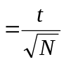 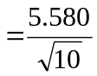 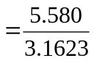 = 1.7645
=> The effect size is VERY Large

Again a Sign Test was Executed:

NPar Tests
Descriptive Statistics
 | N | Mean | Std. Deviation | Minimum | Maximum
before | 10 | 5.40 | 1.955 | 4 | 9
after | 10 | 2.20 | 2.044 | 0 | 5

Sign Test
Frequencies
 |  |  |  | N
after - before | Negative Differencesª |  |  | 8
after - before | Positive Differences^{b} |  |  | 0
after - before | Ties^{c} |  |  | 2
after - before | Total |  |  | 10
a. after < before
b. after > before
c. after = before
Test Statistics^{b}
 |  | after - before
Exact Sig. (2-tailed) |  | .008ª
a. Binomial distribution used.
b. Sign Test

Effect Size for Sign test = ABS(p - 0.5) = ABS(0.008-0.5) = 0.492
=> The effect size is VERY Large

Conclusion:
An experiment to reduce the severity of headaches was conducted on 10 subjects. The treatment was a hypnotism therapy. The researcher recorded the number of pain killers the subjects needed for the headaches before and after the therapy. A t-test was run on the data, which showed a significant difference [t(9) = 5.58, p < .01]. Again, a sign test was executed for this data and found a significant result (N = 10, p < .01). Both the dependent sample t-test and sign test yield the same result. Thus, we reject the null hypothesis. We also conclude that the numbers of pain killers used were less after the hypnotism therapy.

3. Mann-Whitney Test

H_{o} – there is no difference in the sentences passed
H_{a} – there is a difference in the sentences passed

Data:
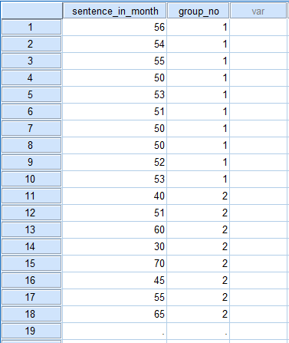

SPSS Output:
T-Test
Group Statistics
 | group_no |  | N | Mean | Std. Deviation | Std. Error Mean
sentence_inmonth | 1 | Group 1 | 10 | 52.40 | 2.171 | .686
sentence_inmonth | 1 | Group 2 | 8 | 52.00 | 13.331 | 4.713

Independent Samples Test
 |  | Levene's Test for Equality of Variances |  | t-test for Equality of Means
 |  | F | Sig. | t | df | Sig. (2-tailed) | Mean Difference | Std. Error Difference | 95% Confidence Interval of the Difference
 |  |  |  |  |  |  |  |  | Lower | Upper
sentence_inmonth | Equal variances assumed | 14.469 | .002 | .094 | 16 | .926 | .400 | 4.253 | -8.616 | 9.416
sentence_inmonth | Equal variances not assumed |  |  | .084 | 7.298 | .935 | .400 | 4.763 | -10.770 | 11.570

First, I tried to do an independent sample t-test to see whether or not there was a homogeneity of variance among the group scores. The Levene’s test was non-significant (p = 0.002<0.01) which indicated that there was no homogeneity of variance among the group scores. That indicated an ineligibility of doing a t-test. So, I tried with a non-parametric Mann-Whitney test.

NPar Tests
Descriptive Statistics
 | N | Mean | Std. Deviation | Minimum | Maximum | Percentiles
 |  |  |  |  |  | 25th | 50th (Median) | 75th
sentence_inmonth | 18 | 52.22 | 8.701 | 30 | 70 | 50.00 | 52.50 | 55.25
group_no | 18 | 1.44 | .511 | 1 | 2 | 1.00 | 1.00 | 2.00

Mann-Whitney Test
Ranks
 | group_no |  | N | Mean Rank | Sum of Ranks
sentence_inmonth | dim1 | Group 1 | 10 | 9.30 | 93.00
sentence_inmonth | dim1 | Group 2 | 8 | 9.75 | 78.00
sentence_inmonth | dim1 | Total | 18

Test Statistics^{b}
 | sentence_inmonth
Mann-Whitney U | 38.000
Wilcoxon W | 93.000
Z | -.178
Asymp. Sig. (2-tailed) | .858
Exact Sig. [2*(1-tailed Sig.)] | .897ª
a. Not corrected for ties.
b. Grouping Variable: group_no

The Mann-Whitney U and Wilcoxon W tests result indicated a non-significant result (N = 18, z = 0.178, p >.05) that failed to reject the null hypothesis, and concluded that there was no significant difference between the two records [U = 38, p = .858].

Effect Size of Mann-Whitney Test:
η²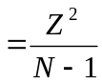 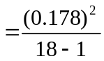 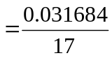 = 0.001863.
=> The effect size is small

Conclusion:
In a study on jury conduct, two samples of juries were asked to pass a sentence to a defendant. Both groups were given the details of the case, but one of the groups was told that some evidence had been withheld from them by the judge. The recommended sentences were recorded and statistical tests were run on them. A Mann-Whitney U test proved that no significant difference existed between the two records (U = 38, p = .858). The effect size was small (η² =0.002). We fail to reject the null and suppose that the two groups more or less passed the same sentences.

- Paired Samples T-Test

H_{o} – there is no difference in cholesterol levels
H_{a} – there is a difference in the cholesterol levels

Data:

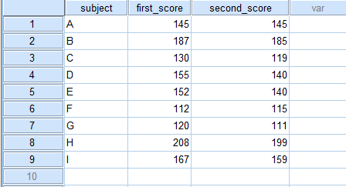

SPSS Output:
T-Test
Paired Samples Statistics
 |  | Mean | N | Std. Deviation | Std. Error Mean
Pair 1 | first_score | 152.89 | 9 | 31.114 | 10.371
Pair 1 | second_score | 145.89 | 9 | 30.592 | 10.197

Paired Samples Correlations
 |  | N | Correlation | Sig.
Pair 1 | first_score & second_score | 9 | .981 | .000

Paired Samples Test
 |  | Paired Differences |  |  |  |  | t | df | Sig. (2-tailed)
 |  | Mean | Std. Deviation | Std. Error Mean | 95% Confidence Interval of the Difference |  | t | df | Sig. (2-tailed)
 |  |  |  |  | Lower | Upper | t | df | Sig. (2-tailed)
Pair 1 | first_score - second_score | 7.000 | 6.000 | 2.000 | 2.388 | 11.612 | 3.500 | 8 | .008

Effect Size for t-test: Cohen’s d 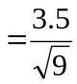 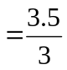 = 1.67
=> The effect size is VERY Large

Again a Sign Test was executed:

NPar Tests
Descriptive Statistics
 | N | Mean | Std. Deviation | Minimum | Maximum | Percentiles
 |  |  |  |  |  | 25th | 50th (Median) | 75th
first_score | 9 | 152.89 | 31.114 | 112 | 208 | 125.00 | 152.00 | 177.00
second_score | 9 | 145.89 | 30.592 | 111 | 199 | 117.00 | 140.00 | 172.00

Sign Test
Frequencies
 |  |  |  | N
second_score - first_score |  | Negative Differencesª |  | 7
 |  | Positive Differences^{b} |  | 1
 |  | Ties^{c} |  | 1
 |  | Total |  | 9
a. second_score < first_score
b. second_score > first_score
c. second_score = first_score
Test Statistics^{b}
 | second_score - first_score
Exact Sig. (2-tailed) | .070ª
a. Binomial distribution used.
b. Sign Test

Effect Size for Sign test = ABS(p - 0.5) = ABS(0.07-0.5) = 0.43
=> The effect size is VERY Large

Conclusion:
An experiment to study the effect of oatmeal on cholesterol levels was carried out. Nine subjects were treated to diets not containing oatmeal for 30 days and then to oatmeal rich diets for the following 30 days. Cholesterol levels were monitored after the two 30-days periods. Statistical tests on the data revealed a significant difference between the levels of cholesterol, a t-test [t(9) = 3.50, p = .008] and a sign test (N = 9, p = .070). Thus, we reject the null, and conclude that the data showed a drop in cholesterol levels after the oatmeal containing diet.

- Paired Sample T-test

H_{o} – there is no difference in the mood between pet and non pet owners
H_{a} – there is a difference in the mood of pet and non pet owners

Data:

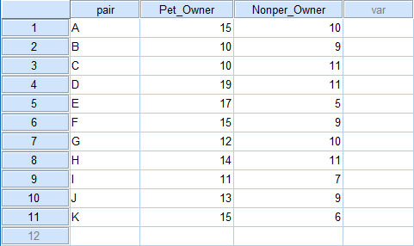

SPSS Output:

Paired Samples Statistics
 |  | Mean | N | Std. Deviation | Std. Error Mean
Pair 1 | Pet_Owner | 13.73 | 11 | 2.867 | .864
Pair 1 | Nonper_Owner | 8.91 | 11 | 2.071 | .625

Paired Samples Correlations
 |  | N | Correlation | Sig.
Pair 1 | Pet_Owner & Nonper_Owner | 11 | -.139 | .683

Paired Samples Test
 |  | Paired Differences |  |  |  |  | t | df | Sig. (2-tailed)
 |  | Mean | Std. Deviation | Std. Error Mean | 95% Confidence Interval of the Difference |  | t | df | Sig. (2-tailed)
 |  |  |  |  | Lower | Upper | t | df | Sig. (2-tailed)
Pair 1 | Pet_Owner - Nonper_Owner | 4.818 | 3.763 | 1.135 | 2.290 | 7.347 | 4.246 | 10 | .002

Effect Size for t-test: Cohen’s d 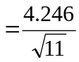 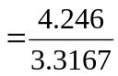 = 1.28
=> The effect size is Large

Again a Sign Test was executed:

NPar Tests

Descriptive Statistics
 | N | Mean | Std. Deviation | Minimum | Maximum
Pet_Owner | 11 | 13.73 | 2.867 | 10 | 19
Nonper_Owner | 11 | 8.91 | 2.071 | 5 | 11

Sign Test

Frequencies
 |  | N
Nonper_Owner - Pet_Owner | Negative Differencesª | 10
Nonper_Owner - Pet_Owner | Positive Differences^{b} | 1
Nonper_Owner - Pet_Owner | Ties^{c} | 0
Nonper_Owner - Pet_Owner | Total | 11
a. Nonper_Owner < Pet_Owner
b. Nonper_Owner > Pet_Owner
c. Nonper_Owner = Pet_Owner

Test Statistics^{b}
 | Nonper_Owner - Pet_Owner
Exact Sig. (2-tailed) | .012ª
a. Binomial distribution used.
b. Sign Test

Effect Size for Sign test = ABS(p - 0.5) = ABS(0.012-0.5) = 0.488
=> The effect size is large

Conclusion:

A researcher examined whether singles with/out pets were happy by comparing the moods of non-pet owners with that of corresponding pet owners. A paired sample t-test result showed a significant difference [t(11) = 4.426, p = .002]. Again, a sign test was executed for this data and found a significant but a little bit different result (N = 10, p <.05). These prompted me to reject the null hypothesis, and conclude that singles who own pets seemed to be happier. The effect size calculated was large.

- Independent Sample T-test
H_{o} – there is a difference in the sentence lengths of whites and blacks.
H_{a} – there is no difference between the lengths of sentences given to whites and blacks.

Data:

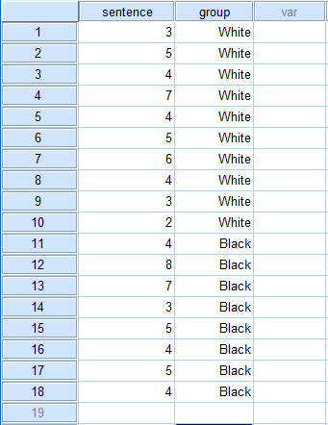

SPSS Output:

SPSS Output:

Group Statistics
 | group | N | Mean | Std. Deviation | Std. Error Mean
sent_in_year | White | 10 | 4.30 | 1.494 | .473
sent_in_year | Black | 8 | 5.00 | 1.690 | .598

Independent Samples Test
 |  | Levene's Test for Equality of Variances |  | t-test for Equality of Means
 |  | F | Sig. | t | df | Sig. (2-tailed) | Mean Difference | Std. Error Difference | 95% Confidence Interval of the Difference
 |  |  |  |  |  |  |  |  | Lower | Upper
sentence | Equal variances assumed | .041 | .843 | -.932 | 16 | .365 | -.700 | .751 | -2.292 | .892
sentence | Equal variances not assumed |  |  | -.919 | 14.179 | .374 | -.700 | .762 | -2.332 | .932

Effect Size: Cohen’s d 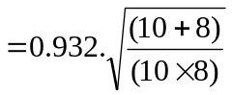 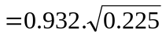 = 0.4420.
=> The effect size is small to medium

Conclusion:

A criminologist examined sentencing related to a defendant’s race. She randomly selected 10 whites and 8 blacks convicted for burglary and compared their sentences using a t-test. The Levene’s test was significant (p = 0.843) which indicated that there was a homogeneity of variance among the group scores. That indicated an eligibility of doing a t-test. Thus, There was no significant difference is the length of prison sentences given to convicts from the two races (t (16) = .932, p = .365). We then fail to reject the null and declare that there is not enough evidence of differences between the lengths of sentence for whites and blacks. The effect size calculated was small to medium.

- Independent Sample T-Test

H_{o} – female smile as much as the males do.
H_{a} – there is a difference in the smiling behaviors of the females and males.

Data:

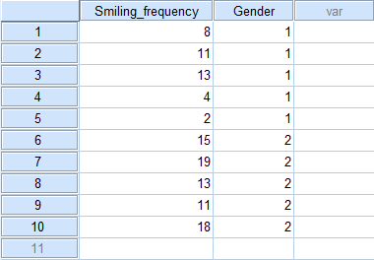

SPSS Output:

Group Statistics
 | Gender | N | Mean | Std. Deviation | Std. Error Mean
Smiling_frequency | Male | 5 | 7.60 | 4.615 | 2.064
Smiling_frequency | Female | 5 | 15.20 | 3.347 | 1.497

Independent Samples Test
 |  | Levene's Test for Equality of Variances |  | t-test for Equality of Means
 |  | F | Sig. | t | df | Sig. (2-tailed) | Mean Difference | Std. Error Difference | 95% Confidence Interval of the Difference
 |  |  |  |  |  |  |  |  | Lower | Upper
Smiling_frequency | Equal variances assumed | .788 | .401 | -2.981 | 8 | .018 | -7.600 | 2.550 | -13.479 | -1.721
Smiling_frequency | Equal variances not assumed |  |  | -2.981 | 7.295 | .020 | -7.600 | 2.550 | -13.579 | -1.621

Effect Size: Cohen’s d 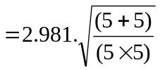 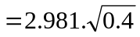 = 1.847.
=> The effect size is large

Conclusion:
A research recorded the number of smiles in a 5-minute interaction for comparison between the female and male smiling behavior. The Levene’s test was significant (p = 0.401) which indicated that there was a homogeneity of variance among the group scores. That indicated an eligibility of doing a t-test. A t-test showed a significant difference (t = 2.981, p = .018). We therefore reject the null and declare that there is evidence that females tend to smile more often than males in a 5-minute interaction. The effect size calculated was large.

- Paired Samples T-Test

H_{o} – there is no effect on the tendency to commit suicide caused by a hero’s suicide.
H_{a} – there is an effect on the tendency to commit suicide caused by a hero’s suicide.
Data:
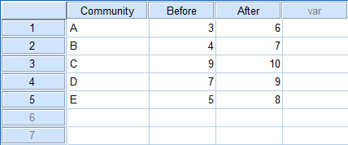

SPSS Output:

T-Test

Paired Samples Statistics
 |  | Mean | N | Std. Deviation | Std. Error Mean
Pair 1 | Before | 5.60 | 5 | 2.408 | 1.077
Pair 1 | After | 8.00 | 5 | 1.581 | .707

Paired Samples Correlations
 |  | N | Correlation | Sig.
Pair 1 | Before & After | 5 | .985 | .002

Paired Samples Test
 |  | Paired Differences |  |  |  |  | t | df | Sig. (2-tailed)
 |  | Mean | Std. Deviation | Std. Error Mean | 95% Confidence Interval of the Difference |  | t | df | Sig. (2-tailed)
 |  |  |  |  | Lower | Upper | t | df | Sig. (2-tailed)
Pair 1 | Before - After | -2.400 | .894 | .400 | -3.511 | -1.289 | -6.000 | 4 | .004
Effect Size for t-test: Cohen’s d 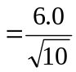 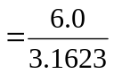 = 1.897
=> The effect size is large

Again a Sign Test was Executed:

NPar Tests
Descriptive Statistics
 | N | Mean | Std. Deviation | Minimum | Maximum
Before | 5 | 5.60 | 2.408 | 3 | 9
After | 5 | 8.00 | 1.581 | 6 | 10

Frequencies
 |  | N
After - Before | Negative Differencesª | 0
After - Before | Positive Differences^{b} | 5
After - Before | Ties^{c} | 0
After - Before | Total | 5
a. After < Before
b. After > Before
c. After = Before

Test Statistics^{b}
 | After - Before
Exact Sig. (2-tailed) | .063ª
a. Binomial distribution used.
b. Sign Test

Effect Size for Sign test = ABS(p - 0.5) = ABS(0.063-0.5) = 0.44
=> The effect size is large

Conclusion:
A research studied whether the tendency to imitate our heroes applied to committing suicide. He collected data on suicide from five communities selected randomly. He compared the rates before and after publicity of a famous singer’s suicide. A t-test (t(5) = 6.00, p = .004) and a sign test (N = 5, p = .063), both showed that there was a significant difference between the rates of suicide before and after the publicity. We reject the null, and conclude that the numbers of suicides went up after publicity was given to the suicide of a famous singer. The effect size calculated was large.

